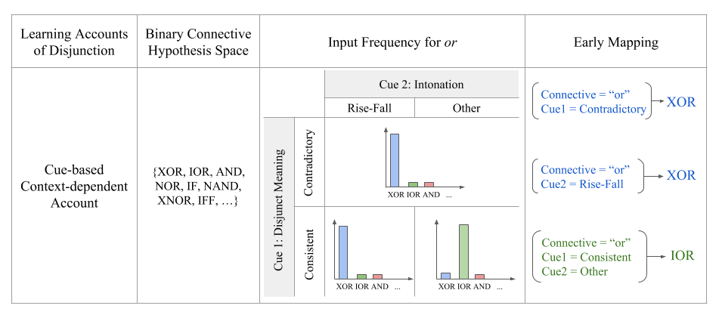Table 2: Cue based, Context Dependent Account Remedies Apparent Contradictions of Usage and Nativist Theories

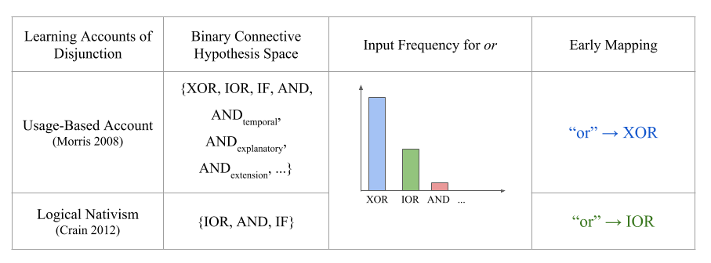

Caption: Summaries of the usage, nativist, and cue-based approaches to disjunction acquisition. For each theory, we present the name, the binary connective hypothesis space considered, the conceptualization of the input frequency for or, and the approximate early mappings constructed by child learners.

Figure 1: Children’s Delayed Development of Or Tracks with Development of Questions



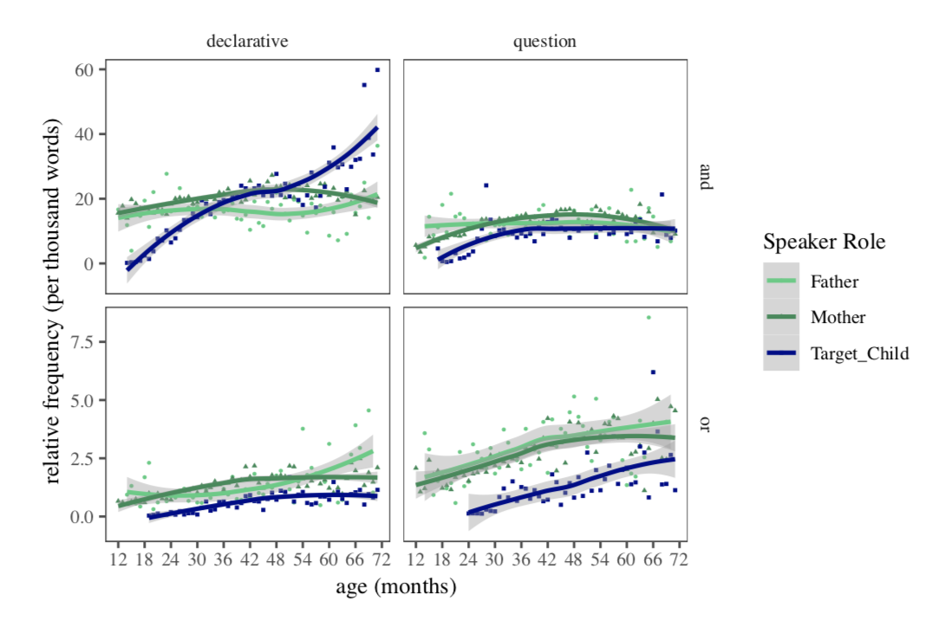



Caption:

Figure 2: Connective interpretation proportion varies with significant contextual cues



Insert model results here



Figure 3: Exclusive and Inclusive interpretations are contextually dependent



Caption: (A) Proportion of exclusive and inclusive interpretations of disjunction in child-directed speech. Error bars represent bootstrapped 95% confidence intervals. (B) Exclusive and inclusive interpretations broken down by intonation (flat, rise, rise-fall) and consistency. Error bars represent bootstrapped 95% confidence intervals.

Figure 4: A Decision Tree Can Distinguish XOR and IOR using intonation and consistency

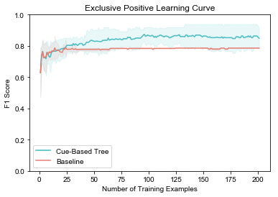

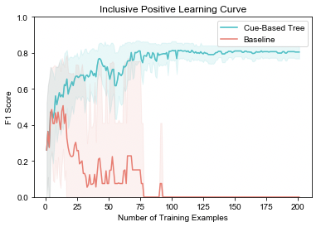

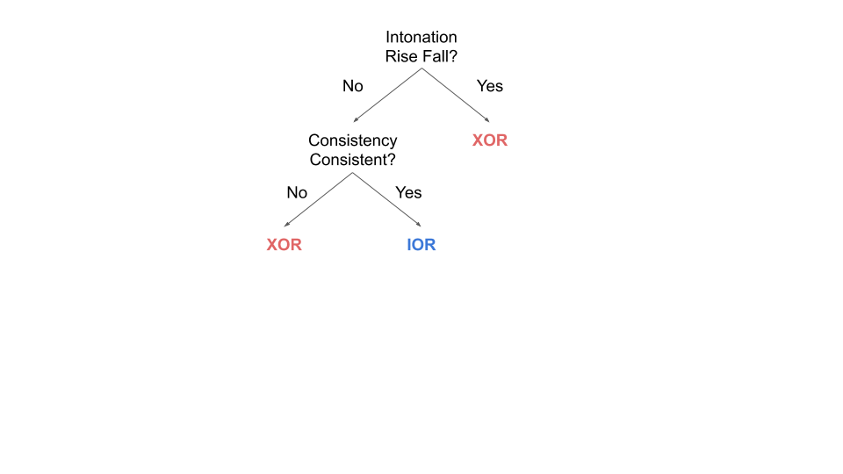

Caption: (A) The structure for the baseline (highest gini threshold, 0.2) decision tree trained on examples with XOR and IOR interprtations. (B) The structure for the tree with gini threshold of 0.01. (C) The average F1 score for XOR with 95% confidence intervals as a function of the number of training examples in the baseline and cue-based model. (D) The average F1 score for IOR with 95% confidence intervals for the baseline and cue based models

Figure 5: A Decision Tree Can Distinguish XOR, IOR, AND, and NOR using context cues

